Assignment Stage 2 Report - Group 26
36100 Data Science for Innovation - Spring 2025

Mason Pun | 25451713
Jiayu Hao | 25948860
Yan Hao | 25976440
Ting Chen | 25649649

Section 1: Literature review 3
Section 2: Setup 4
Research questions 4
Hypotheses Formation 4
Reliability and Effectiveness 5
Data 5
Section 3: Approach 5
Section 4: Results 6
4.1 Model performance and reliability 6
4.2 Comparison with Literature Review 7
4.3 Error analysis 7
4.4 Feature influence 9
4.5 Critical analysis 11
4.6 Addressing our Research Questions 12
Section 5: Conclusion 12
References 13

Section 1: Literature review
Recent studies have shown us the potential for effective obesity classification through the use of machine learning. Our two level strategy, using Logistic Regression as a baseline and Gradient Boosting as a benchmark, draws on established research to validate these model choices, due to their effectiveness and ease of use.
Estimation of Obesity Levels through the Proposed Predictive Approach Based on Physical Activity and Nutritional Habits - Gozukara Bag et al (2023)
Gozukara Bag and colleagues proposed a tree-based classification approach using data gathered through online surveys. Their study applied Logistic Regression, Random Forest and Gradient Boosting algorithms, following the reasoning “because they are easy to apply, have a high accuracy rate in many problems, and can be applied quickly”. Similarly to our dataset, they addressed class imbalance through the use of SMOTE and improved their model through Recursive Feature Elimination, a recursive setup that goes through all features of a model and removes the least weighted one, until the desired number of remaining features is met. Finally, they used Bayesian Optimisation for their hyperparameter tuning.

This supports our use of Logistic Regression as a baseline and Gradient Boosting as a benchmark. It also validates the integrity of our dataset, which has been balanced using SMOTE - a standard practice in the field.
Prediction and classification of obesity risk based on a hybrid metaheuristic machine learning approach - Helforoush & Sayyad (2024)
This study uses a hybrid ANN-PSO Model for obesity risk prediction, performing with a 92% accuracy metric, a considerable high accuracy value. Throughout their testing, both Logistic Regression and Gradient Boosting models were used, supporting our choice of models. A key part to highlight is their focus on feature engineering: 2 features they created “Meal Habits and Activity balance that combine features derived from the dataset allowing further performance improvements.
Their approach supports our decision to include simple feature engineering in our data preparation and further validates our selection of Logistic Regression and Gradient Boosting.
XAI-Enhanced Machine Learning for Obesity Risk Classification: A Stacking Approach With LIME Explanations - Azad et al. (2025)
Azad et al. developed a stacked ensemble model, combining LightGBM, Logistic Regression, and Random Forest, with Stochastic Gradient Descent. Stacked ensemble models combine multiple base models by training a final "meta-model", that learns how best to combine the predictions of the base models together to proceed to an optimised final result. Their model achieved approximately 98% accuracy which is extraordinarily high, with feature importance analysis highlighting the importance of weight, height, age and family history as the key predictors for the model.
This study reinforces the value of combining interpretable and high-performing models like Logistic Regression and Gradient Boosting. Their emphasis on feature importance aligns with our own focus on understanding key predictors in addition to performance metrics.

Using interpretable machine learning methods to identify the relative importance of lifestyle factors for overweight and obesity in adults - Sun et al. (2024)
Sun et al. (2024) conducted a large-scale study with a key focus on feature importance, to provide interpretability. Their data was sourced from 2 surveys: The China Health and Nutrition Survey (CHNS) and the National Health and Nutrition Examination Survey (NHANES), two freely accessible, high-quality, and widely used nationwide surveys that encompass a broad range of lifestyle factors and health data. For modelling, they used Decision trees, Random Forest and Gradient Boosting Decision Trees and combined these models with SHAP (SHapley Additive exPlanations) which allowed for detailed and transparent feature weighting. As a result, they identified that the key features for obesity included: sedentary behavior, alcohol consumption, and protein intake. Notably, there were specific risk thresholds such as sedentary time exceeding 35 hours/week and alcohol consumption above 7 cups/week, that significantly increased obesity risk.
This approach reinforces our emphasis on interpretability and supports our use of Permutation Feature Importance to provide interpretability for our features after PCA is applied for modelling optimisation. Moreover, it highlights that interpretability should not be limited to model transparency alone, but must also include an understanding of which features drive predictions. By focusing on feature importance alongside model performance, we can uncover actionable insights and ensure that our models results are interpretable for the general audience, rather than simply achieving high performance metrics.

Section 2: Setup

Research questions
This project focuses on predicting obesity levels based on individuals’ eating habits and physical activity using machine learning techniques. The study aims to address the following research questions:

- Predictive Modelling:
  - What level of accuracy can machine learning models achieve when classifying obesity level?
- Feature Importance:
  - Which lifestyle and demographic factors most strongly influence the obesity classification for this dataset?
- Model Optimisation:
  - How does limiting or manipulating our feature set in combination with applying preprocessing techniques affect classification accuracy and interpretability?

Hypotheses Formation
Model-comparison hypotheses (Primary):
H₀: The predictive performance (Accuracy) of the gradient boosting model is equal to the predictive performance of logistic regression.
H₁: The predictive performance (Accuracy) of the gradient boosting model is different (higher) than that of logistic regression.
This hypothesis directly compares the two machine learning algorithms to determine whether the advanced, nonlinear Gradient Boosting approach provides a significant improvement over the baseline Logistic Regression model in classifying obesity levels.
Feature-association hypotheses (Secondary):
H₀: The coefficient for predictor X (such as age / transportation method) equals 0.
H₁: The coefficient for X (such as age / transportation method) is not 0.
This hypothesis evaluates whether specific lifestyle or demographic factors have a statistically meaningful association with obesity risk. Feature-association analysis will be conducted only on the model with superior predictive accuracy.

Reliability and Effectiveness
Model Reliability
To assess model reliability, we will use 5-fold cross-validation to ensure consistent results across different data splits. This approach reduces the influence of random variation, particularly in Gradient Boosting, and provides a stable estimate of model generalization. Additionally, we will perform a 5×2 cross-validation paired t-test at a 0.05 significance level (95% confidence) to evaluate whether the advanced gradient boosting model is significantly better than the baseline logistic regression model.
Effectiveness
Model effectiveness will be evaluated primarily by Accuracy and F1-Score, capturing overall performance and the balance between precision and recall. Additional metrics such as AUC and confusion metrics will be considered for deeper evaluation or error analysis where needed.
For feature importance, we will interpret it through Logistic Regression coefficients, and Permutation Importance with a table, to identify the key factors that most influence obesity predictions.

Data
We use the dataset “Estimating Obesity Levels Based on Eating Habits and Physical Condition” containing 2,111 records from Colombia, Peru, and Mexico. Variables include age, gender, physical-activity level, frequency of high-calorie food intake, water consumption, and calorie intake awareness. Data were processed, encoded, and standardized as appropriate before modeling.In addition, a derived feature Body Mass Index (BMI) was computed from Weight and Height according to WHO standards. This variable was explored during the EDA phase and was later tested separately as a validation feature, as it directly measures physical condition and may enhance interpretability of the classification models.

Section 3: Approach
We will approach this classification problem using a two level modelling strategy, our baseline model will be logistic regression, selected for its simplicity and effectiveness. As a comparison, we will also be implementing a Gradient boosting as a more advanced benchmark. Both models share the same preprocessing pipeline to ensure a fair comparison.
The dataset has already been balanced using SMOTE as part of the initial dataset. Originally in Part 1 for this assignment, we wanted to compare the models with the artificial data generated by SMOTE, vs without. However due to limitations of the dataset, the data is not labelled and we are unable to distinguish between the original and synthetic samples. Due to this limitation, we will proceed by training and evaluating our models on the dataset in its current form, treating all data entries equally.
In addition to the feature engineering that was applied in the data engineering stage, we also will incorporate Principal Component Analysis (PCA) during the modelling process. PCA transforms correlated input features into a set of orthogonal components, with our usage trying to reduce multicollinearity to reduce the effect of highly correlated features affecting our model’s development. Due to the side effect of PCA simplifying features, this reduces the interpretability of the features, especially when it comes to feature analysis. As a result of this, we will be using permutation feature importance to investigate features weights, bypassing the side effects of PCA’s dimensionality reduction.
To address our Research questions, the following steps will be taken:
- Hyperparameter tuning: We will apply strategies for hyperparameter tuning such as Grid Search, to attempt at maximising the models performance in order to boost our level of accuracy for classification, addressing our first research question.
- We will investigate feature weights for the completed models, to determine which lifestyle or demographic factors most strongly influence the obesity classification. Furthermore, using feature engineering from Part 1 of the report, we will also investigate how our engineered features are weighted and perform at determining the obesity classification.

Section 4: Results

4.1 Model performance and reliability
Gradient Boosting reached slightly higher scores than Logistic Regression, but the difference is small.
Bootstrap confidence intervals show that both models perform very consistently, with narrow ranges around 0.97 macro F1.
After hyperparameter tuning and evaluation, the final model performance is shown in Table 1.
Model | CV Macro-F1 (mean ± sd) | Test Accuracy (95 % CI) | Test Macro-F1 (95 % CI)
Logistic Regression | 0.9598 ± 0.006 | 0.967 (0.953 – 0.980) | 0.966 (0.952 – 0.980)
Gradient Boosting | 0.9683 ± 0.006 | 0.969 (0.954 – 0.981) | 0.967 (0.953 – 0.981)
Table 1. Model performance comparison with 95 % confidence intervals
In order to confirm the reliability of the models, a 5×2 cross-validation paired t-test was performed. The result (t = −1.35, p = 0.24) shows that there is no significant difference between the two models. This supports our null hypothesis H₀ and suggests that the simpler Logistic Regression performs as reliably as Gradient Boosting for this dataset but also includes the benefits of running faster, and being a simpler model for interpretation due to its linearity.

4.2 Comparison with Literature Review
The accuracy of both models (~97%) is close to the values reported in previous research such as Gozukara Bag et al. (2023) and Azad et al. (2025), which achieved around 96–98 % using similar datasets.
This confirms that our preprocessing and feature selection follow accepted methods in obesity classification and reach a comparable benchmark.

4.3 Error analysis
Most obesity levels were correctly identified by both models, with particularly strong performance across the majority of classes. The only notable confusion occurred between Normal Weight (Label 1) and Overweight Level I (Label 2), which were occasionally misclassified. This overlap is expected, as individuals in these categories often share similar lifestyle attributes, such as moderate physical activity, balanced meal frequency, and comparable calorie awareness, making them harder to distinguish based solely on the available features.
Despite this, recall scores for all other classes exceeded 0.97, indicating excellent sensitivity and minimal false negatives. The confusion matrix (Figure 1) confirms that misclassifications were isolated to just Label 1 and 2, and did not reflect a systematic bias across the dataset. This suggests that the SMOTE balancing technique applied to the dataset was effective in preserving class boundaries and preventing overfitting to dominant categories.
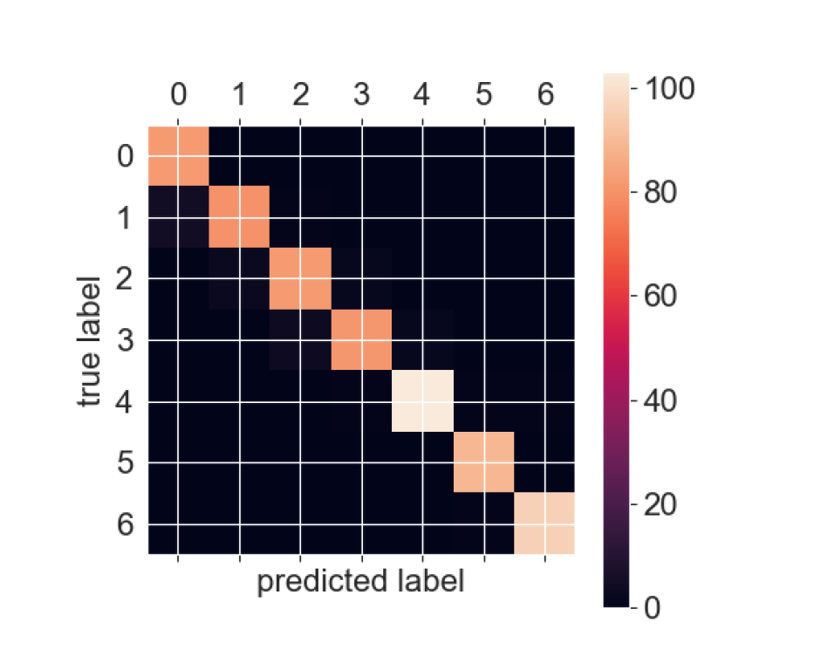

Figure 1. Normalised confusion matrix for Gradient Boosting model showing classification accuracy across seven obesity levels.
0: Insufficient_Weight
1: Normal_Weight
2: Overweight_Level_I
3: Overweight_Level_II
4: Obesity_Type_I
5: Obesity_Type_II
6: Obesity_Type_III
To further verify reliability, receiver-operating-characteristic (ROC) curves for selected classes are presented in Figure 2. All classes achieved area-under-curve (AUC) values above 0.95, demonstrating excellent discrimination between labels, even in borderline cases.
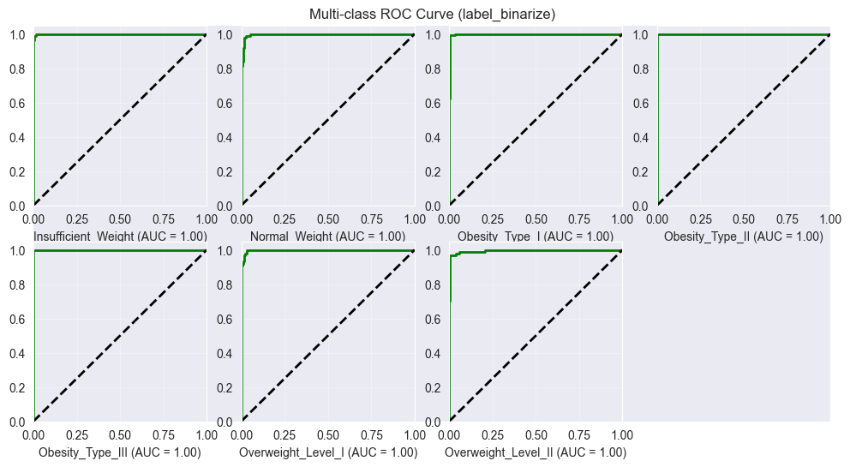
Figure 2: Receiver operating characteristic (ROC) curves for selected obesity classes (one-vs-rest evaluation).

4.4 Feature influence
Feature importance was examined using two methods: Permutation Feature Importance and combining the Logistic Regression coefficients with their PCA weights.
The top features were ranked by overall influence from permutation Feature Importance, while the coefficients show the direction (positive / negative) of each effect.
Table 2 lists the ranked results, sorted by descending importance.
Rank | Feature | Permutation Feature Importance | Coefficient (Sign) | Interpretation
1 | Weight | 0.760 | −94.89 (negative) | Higher weight strongly increases obesity risk (most influential).
2 | Height | 0.380 | 25.12 (positive) | Height relates to BMI; taller individuals with lower weight are less likely obese.
3 | Gender | 0.135 | 3.82 (Male positive) | Males slightly more likely classified in higher obesity levels.
4 | FCVC (Vegetable intake frequency) | 0.084 | 0.11 (positive) | Lower vegetable intake is linked to higher risk.
5 | CALC (Alcohol consumption) | 0.062 | 1.01 (positive) | Frequent alcohol use shows a weak positive association with obesity.
6 | NCP (Main meals per day) | 0.029 | −0.28 (negative) | Having fewer than three meals is associated with overweight risk.
7 | Age | 0.025 | −1.10 (negative) | Older age moderately increases obesity risk.
8 | Family history (overweight) | 0.018 | −0.43 (negative) | Indicates genetic predisposition to obesity.
9 | MTRANS (Transport mode) | 0.018 | −3.71 (Public Transport) | Less active transport modes increase risk.
10 | CAEC (Eating between meals) | 0.008 | 2.30 (Frequent) | Frequent snacking is linked to higher obesity types.
11 | CH2O (Water intake) | 0.006 | 0.70 (positive) | Higher water intake slightly reduces obesity risk.
12 | FAVC (High-calorie food) | 0.005 | 0.35 (positive) | Frequent high-calorie consumption increases risk.
13 | TUE (Screen time) | 0.004 | 0.11 (positive) | Longer screen time correlates with higher obesity.
14 | FAF (Physical activity) | 0.004 | 0.25 (positive) | Lower activity reduces energy expenditure and raises risk.
15 | SMOKE | 0.002 | 0.09 (positive) | Weak and inconsistent association.
16 | SCC (Calorie monitoring) | 0.000 | −0.11 (negative) | Monitoring calories slightly reduces obesity risk.
Table 2: Feature importance ranked by permutation importance with coefficient direction from Logistic Regression (PCA weights)
Feature importance analysis reinforces the patterns observed in both our exploratory data analysis and the supporting literature. The rankings clearly show that body-measurement features dominate model performance, with weight contributing more than twice as much as height - together accounting for the majority of predictive weight. Lifestyle and behavioural factors, such as diet, physical activity, and alcohol intake, exert a moderate influence, while psychosocial variables like calorie awareness (SCC) demonstrate a minor yet consistent influence. These results confirm that obesity risk is primarily driven by measurable physical conditions and daily habits such as physical activity and calorie intake. Moreover, the direction of the model coefficients aligns with established health patterns, lending further support to the interpretability and validity of our findings.

4.5 BMI Validation
To verify the consistency between our models and established medical indicators, we tested BMI-based classification following WHO standards.

BMI Range (kg/m²) | Category
bmi < 18.5 | Insufficient_Weight
18.5 ≤ bmi < 25 | Normal_Weight
25 ≤ bmi < 30 | Overweight
30 ≤ bmi < 35 | Obesity_Type_I
35 ≤ bmi < 40 | Obesity_Type_II
bmi ≥ 40 | Obesity_Type_III
Table 3. WHO International BMI Classification Standards (Ages 18 and Above)

The BMI-only classifier achieved 95% accuracy (macro F1 = 0.95) when mapping individuals into six obesity categories.

Class | Precision | Recall | F1-Score | Support
Insufficient_Weight | 0.99 | 0.99 | 0.99 | 223
Normal_Weight | 0.97 | 0.99 | 0.98 | 262
Obesity_Type_I | 0.94 | 0.99 | 0.96 | 343
Obesity_Type_II | 0.83 | 0.94 | 0.88 | 297
Obesity_Type_III | 1.00 | 0.83 | 0.91 | 324
Overweight | 1.00 | 0.98 | 0.99 | 549
Accuracy | — | — | 0.95 | 1998
Macro avg | 0.95 | 0.95 | 0.95 | 1998
Weighted avg | 0.96 | 0.95 | 0.95 | 1998
Table 4. BMI-Based Classification

This result demonstrates that BMI alone already provides substantial predictive power, and that our machine learning models extend this by incorporating behavioural and lifestyle information.
These findings reinforce that obesity risk in our dataset is mainly explained by measurable physical conditions—consistent with our feature-importance analysis and prior studies.

4.6 Critical analysis
Firstly, while both models achieved high performance metrics, several limitations from our dataset constrain further improvement. The inclusion of synthetic samples via SMOTE, applied as part of the dataset, may have smoothed class boundaries, potentially inflating performance metrics and masking subtle classification errors. Despite our earlier analysis showing that SMOTE was effectively used in this dataset to preserve class boundaries and prevent overfitting to dominant categories, it is still artificially generated and a model using non-artificial data, may provide a more realistic performance analysis, especially from a business perspective of interpretability..
Secondly, the PCA step applied in the preprocessing stage improved model stability, but reduced interpretability due to the coefficients being based on the principal components created during PCA, rather than the raw features.
Thirdly, Gradient Boosting requires a longer training time and offers less transparency due to its black-box nature. This reduces its usefulness in a health-care decision-making environment where interpretability is key to allow users to explain to their clients the results derived from machine learning analysis.
Finally, future work to expand on this study could include testing models on non-artificial data, exploring more explainable and better interpreted boosting methods, or including new behavioural features such as sleep and diet timing to expand the accessible features for model development..

4.7 Addressing our Research Questions
This study evaluated two machine-learning approaches - Logistic Regression and Gradient Boosting - for predicting obesity levels using lifestyle and physical-condition data. After our model development and results analysis, we have answered our research questions below.
- Predictive Modelling
What level of accuracy can machine learning models achieve when classifying obesity level?
Both Logistic Regression and Gradient Boosting achieved high and consistent classification accuracy, with test scores around 97%. Statistical testing (p = 0.24) showed no significant difference between the models, confirming that reliable predictions can be obtained using either approach.
- Feature Importance
Which lifestyle and demographic factors most strongly influence the obesity classification for this dataset?
Feature importance analysis revealed that weight, height, gender, physical activity frequency, and calorie-intake awareness were the most influential predictors. With Gender and Height being unchangeable for individuals, and weight being directly correlated to obesity, physical activity frequency and calorie intake are the 2 key factors to reducing obesity and managing an individual’s health.
These findings align with prior research and validate the relevance of both physiological and behavioral factors in obesity classification.
- Model Optimisation
How does limiting or selecting different feature sets in combination with applying preprocessing techniques affect classification accuracy and interpretability?
Applying Principal Component Analysis (PCA) improved model performance and stability by reducing dimensionality, but at the cost of direct interpretability. To address this, Permutation Feature Importance was used post-PCA to recover insight into feature influence. This approach allowed us to retain performance gains while still identifying key predictors, balancing accuracy with interpretability. Due to the nature of health-care and the importance of interpretability, for future studies it may be a better decision to keep all features in their raw forms to allow for maximum interpretability.

Section 5: Conclusion
As a conclusion, both models performed similarly, however our cross-validation paired t-test shows that Logistic Regression is as reliable as Gradient Boosting and our performance metrics show that it performed very similar to Gradient Boosting, in addition to running faster due to it being a simpler model. Therefore, Logistic Regression is our recommendation for obesity-risk classification, while future studies could extend validation to real-world or cross-country data.

References

Azad, M., Khan, M. F. K., & El-Ghany, S. A. (2025). XAI-enhanced machine learning for obesity risk classification: A stacking approach with LIME explanations. IEEE Access, 13, 13847–13865. https://doi.org/10.1109/ACCESS.2025.3530840

Gozukara Bag, H. G., Yagin, F. H., Gormez, Y., González, P. P., Colak, C., Gülü, M., Badicu, G., & Ardigò, L. P. (2023). Estimation of obesity levels through the proposed predictive approach based on physical activity and nutritional habits. Diagnostics, 13(18), 2949. https://doi.org/10.3390/diagnostics13182949

Helforoush, Z., & Sayyad, H. (2024). Prediction and classification of obesity risk based on a hybrid metaheuristic machine learning approach. Frontiers in Big Data, 7. https://doi.org/10.3389/fdata.2024.1469981

Sun, Z., Yuan, Y., Farrahi, V., Herold, F., Xia, Z., Xiong, X., Qiao, Z., Shi, Y., Yang, Y., Qi, K., Liu, Y., Xu, D., Zou, L., & Chen, A. (2024). Using interpretable machine learning methods to identify the relative importance of lifestyle factors for overweight and obesity in adults: Pooled evidence from CHNS and NHANES. BMC Public Health, 24, Article 3034. https://doi.org/10.1186/s12889-024-20510-z

